Infosys Springboard Virtual Internship 6.0 Completion Report

Team Details

Batch Number: 3
Start date: 4th September, 2025
Names: Adithya Ramesh
Rithika Varaganti
Shaik DurveshAli
Neha Sadhvi Polepaka
Internship Duration: 8 Weeks

1. Project Title
“QuickServe Localized Service Discovery and Booking App”

2. Project Objective
The main objective of the Local Service Finder and Booking Platform is to develop a robust, scalable, and interactive application that simplifies the process of discovering, booking, and managing local services for users in different geographical areas. The platform aims to bridge the gap between service providers and customers by providing a unified digital system that ensures convenience, transparency, and efficiency in service transactions.
The project focuses on utilizing modern software development principles and Java-based architecture to design an efficient, user-centric solution that caters to the real-world challenges of local service discovery. It provides a seamless interface that enables users to search for nearby services, compare options, and make bookings based on availability and ratings, while allowing service providers to manage their listings and schedules effectively.
The key objectives of the project are as follows:
- To create a centralized digital platform that connects customers and service providers, eliminating the need for manual or offline service discovery.
- To implement role-based authentication for three distinct user types — Customer, Service Provider, and Administrator — ensuring secure and personalized access control.
- To enable real-time service search and booking, allowing users to check availability and schedule appointments with minimal effort.
- To incorporate intelligent filtering and location-based search mechanisms that enhance the accuracy and relevance of search results.
- To integrate a feedback and rating system that promotes reliability and accountability among service providers while assisting customers in decision-making.
- To design an admin module that allows for moderation of new listings, approval or rejection of services, and analytics to monitor platform performance.
- To maintain data integrity and scalability through an efficient database schema and modular code structure, ensuring ease of future enhancements.
- To enhance user experience by providing intuitive navigation, interactive dashboards, and smooth data flow between modules.
By achieving these objectives, the project strives to deliver a complete digital solution that streamlines the local service discovery and booking process. It empowers users with convenience and service providers with visibility, fostering a mutually beneficial digital ecosystem that can evolve with technological advancements such as AI-based recommendations and integrated payment gateways in the future.

3. Project description in detail
The Local Service Finder and Booking Platform is a comprehensive web-based application designed to connect customers with local service providers efficiently and transparently. The primary goal of the project is to create a one-stop digital solution where users can discover, evaluate, and book professional services based on their specific needs and geographical proximity. This platform ensures mutual benefits for both customers and service providers by bridging the communication gap, improving accessibility, and promoting trust through verified listings and reviews.
In the existing scenario, customers often face several challenges such as difficulty in finding reliable local professionals, lack of standard pricing, and time-consuming manual searches. Service providers, on the other hand, struggle to reach a broader audience due to limited digital presence. The Local Service Finder and Booking Platform addresses these challenges by enabling real-time interaction between customers and providers through a secure, structured, and easy-to-use online interface.
System Overview
The platform is designed with a three-tier architecture consisting of:
- Presentation Layer: The user interface that allows customers and service providers to interact with the system through intuitive dashboards.
- Business Logic Layer: The core processing layer developed in Java that handles all application logic, authentication, and booking management.
- Data Layer: The backend database that securely stores user profiles, service listings, booking records, and feedback data.
The project employs role-based access control, ensuring that each type of user—Customer, Service Provider, and Administrator—has specific functionalities and privileges.
- Customers can search for services based on categories, location, or keywords; check service availability; book appointments; and leave feedback after completion.
- Service Providers can register on the platform, create and manage their service listings, define pricing and schedules, and view their booking requests.
- Administrators are responsible for approving or rejecting service provider listings, maintaining the integrity of the platform, and viewing analytical reports related to service demand and user engagement.
Core Functional Modules
- User Authentication and Role Management:
A secure login and registration system that differentiates between customers, providers, and administrators.
- Service Listing and Search:
Service providers can create, edit, or delete listings. Customers can filter results based on service type and location.
- Booking and Scheduling:
A dynamic booking calendar allows customers to view provider availability and select suitable time slots, preventing double bookings.
- Ratings and Reviews:
Customers can rate services and write feedback to maintain transparency and encourage service quality.
- Admin Panel:
The admin oversees the overall functionality of the platform, manages service approvals, and generates usage statistics for analysis.
Technology Stack
- Frontend: Java Swing / JSP for user interface design.
- Backend: Java with JDBC for logic handling and database connectivity.
- Database: MySQL for storing and managing all data entities.
- Tools Used: NetBeans / Eclipse IDE for development and XAMPP for database management.
Key Features
- Simple and user-friendly interface.
- Location-based filtering for quick discovery.
- Real-time availability updates.
- Role-specific dashboards for better control.
- Rating and feedback mechanism for transparency.
- Secure and reliable booking system.
Benefits
- Provides a centralized system for easy service discovery and booking.
- Increases digital visibility and customer reach for small-scale service providers.
- Reduces manual efforts and saves time for customers.
- Ensures a secure and transparent transaction environment.

4. Timeline Overview

Week | Activities Planned | Activities Completed
Week 1 | Authentication Module | Login & Signup Module
Week 2 | Role based Authorization | Role based Authorization
Week 3 | Provider Dashboard | Provider Dashboard
Week 4 | Customer Dashboard | Customer Dashboard
Week 5 | Booking Module | Booking Module
Week 6 | Booking Module | Booking Module
Week 7 | Rating Module | Rating Module
Week 8 | Admin Module | Admin Module

5a. Key Milestones

Milestone | Description | Date Achieved
Project Kickoff | Conducted the initial team meeting to discuss project goals, scope, and timeline. Roles and responsibilities were assigned to each member, and the project plan was finalized | 04-Sep-2025
Prototype/First Draft | Designed the basic framework of the system, including user interface layout and database structure. Implemented core modules for initial testing | 18-Sep-2025
Mid-Term Review | Shared the working prototype with the mentor, received valuable feedback, and made improvements in functionality and UI design | 09-Oct-2025
Final Submission | Completed the final version of the project after integrating all modules. Conducted testing and documentation preparation. | 27-Oct-2025
Presentation | Delivered the final project presentation demonstrating workflow, technical implementation, and real-world use cases | 03-Nov-2025

5b. Project execution details
The project Local Services Finder and Booking Platform was executed in multiple phases over an eight-week development cycle. The execution followed an incremental and modular approach, ensuring each component was developed, tested, and integrated systematically. The project aimed to build a user-friendly web-based platform that connects customers with local service providers for various needs such as plumbing, tutoring, cleaning, and more.
Phase 1: Requirement Analysis and Design (Week 1)
During the initial stage, the project team conducted a thorough analysis of user needs and functional requirements. Detailed use cases were prepared to identify the roles of customers, service providers, and administrators. System design documents, including the data flow and architecture diagrams, were created to visualize the overall structure. This phase laid the foundation for defining database schema, modules, and the user interface flow.
Phase 2: Authentication and Role Management (Weeks 1–2)
The first milestone involved setting up a secure authentication system. Separate login and registration modules were developed for two primary roles—Customer and Service Provider. Role-based access control was implemented to ensure that each user type had specific permissions and dashboard views. Service providers were required to complete their profiles, selecting relevant service categories, availability schedules, and contact details.
Phase 3: Service Listings and Filtering (Weeks 3–4)
Once authentication was complete, the focus shifted to developing the listings and search modules. Service providers were enabled to create, edit, and delete their service listings with key details such as name, description, price, service area, and optional images. For customers, an efficient search and filter mechanism was designed to find services based on category, keywords, and geographic area. The results were dynamically displayed and prioritized according to relevance and proximity.
Phase 4: Booking Management (Week 5)
In this stage, the booking calendar module was developed. It allowed customers to view available time slots for a particular service and schedule appointments in real time. The system automatically prevented double bookings by updating availability as soon as a slot was confirmed. Booking confirmations were sent to both customers and service providers, and users could track their booking status—Pending, Confirmed, or Completed—through their respective dashboards.
Phase 5: Ratings and Feedback Integration (Weeks 6–7)
This phase aimed to enhance user engagement and trust. A rating system was implemented, allowing customers to provide 1–5 star ratings and optional feedback after a service completion. The collected ratings were displayed on provider profiles to help future customers make informed decisions. Users were also able to review their past service history and feedback records from their dashboard.
Phase 6: Admin Control and Analytics (Week 8)
The final phase of execution involved the development of the Admin Panel. The admin was provided with functionalities to approve, reject, or flag new service provider listings. Additionally, an analytics dashboard was integrated to track the platform’s performance, showing the most booked service categories, top-rated providers, and overall platform usage statistics. This ensured system moderation, quality assurance, and data-driven decision-making for future improvements.
Testing and Integration
After completing each module, comprehensive testing was performed to ensure smooth functionality and compatibility across all components. Unit testing, integration testing, and user acceptance testing (UAT) were conducted to validate system performance, usability, and reliability. All modules were successfully integrated to form a cohesive and interactive platform.
Tools and Technologies Used
- Front-end: HTML, CSS, JavaScript
- Back-end: Java (JSP, Servlets)
- Database: MySQL
- Version Control: GitHub
Outcome of Execution
The successful execution of this project resulted in a functional prototype of a Local Services Finder and Booking Application. It provided:
- Role-based dashboards for customers and service providers.
- A real-time booking and scheduling system.
- An interactive review and rating mechanism.
- A secure and moderated environment for managing listings.
- Analytical insights for administrators to monitor platform growth.

6. Snapshots / Screenshots

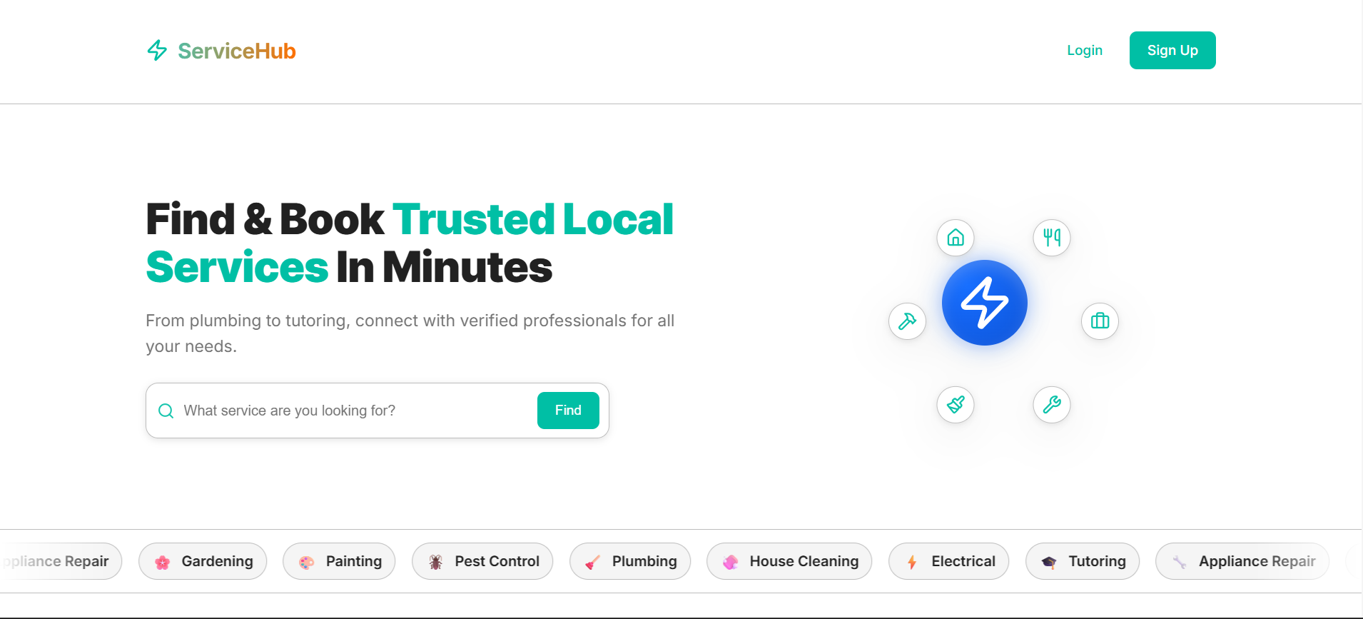

Figure 1: Landing Page

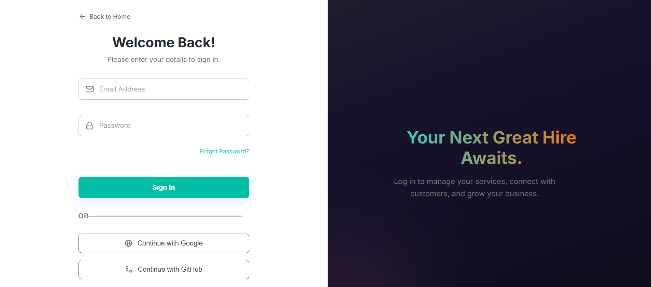
Figure 2: Login Page

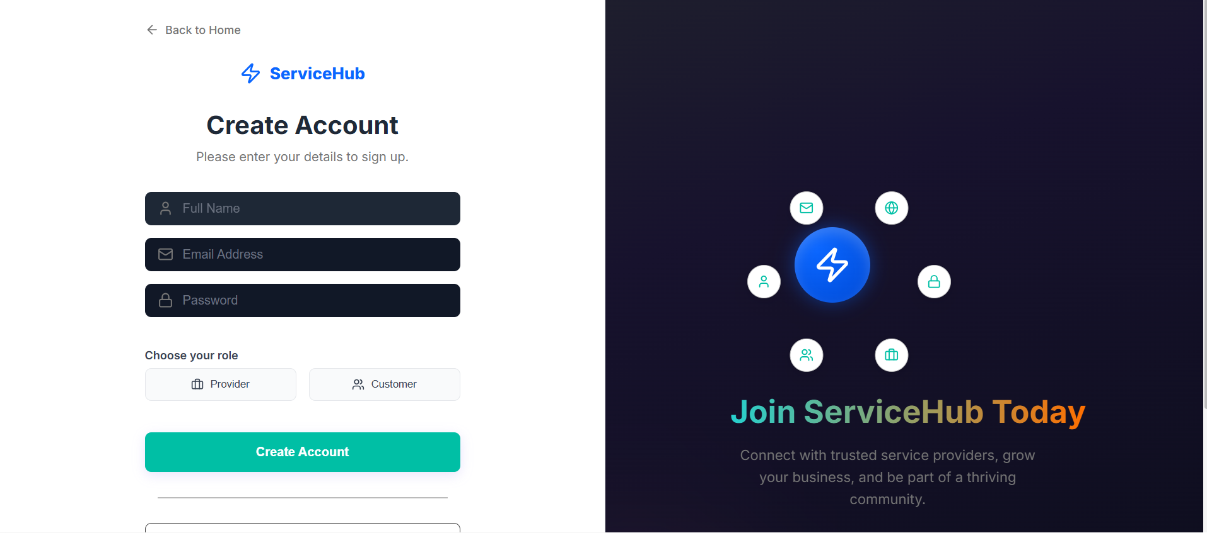
Figure 3: Signup Page

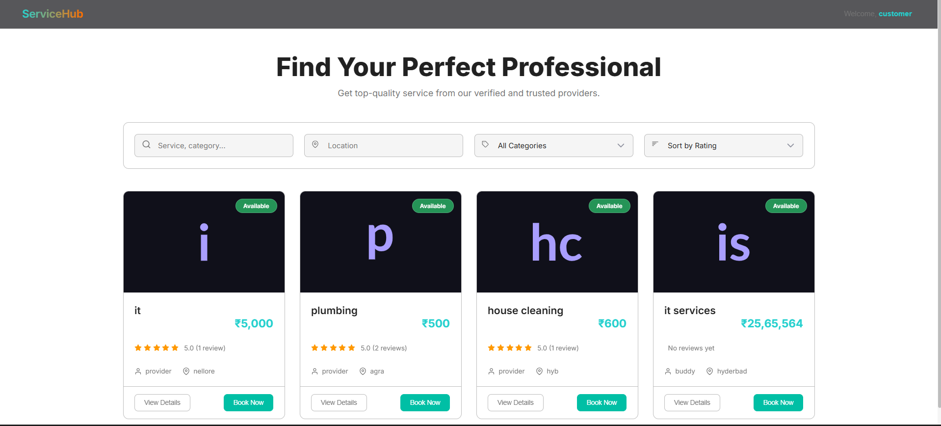
Figure 4: Customer Dashboard

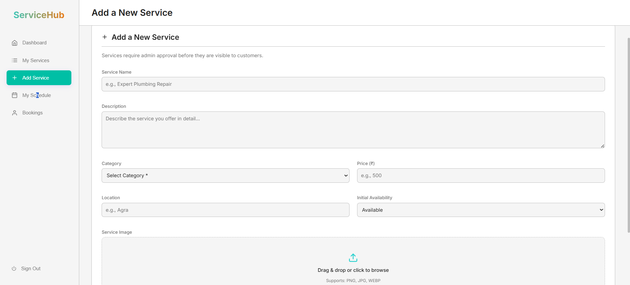

Figure 5: Provider Dashboard

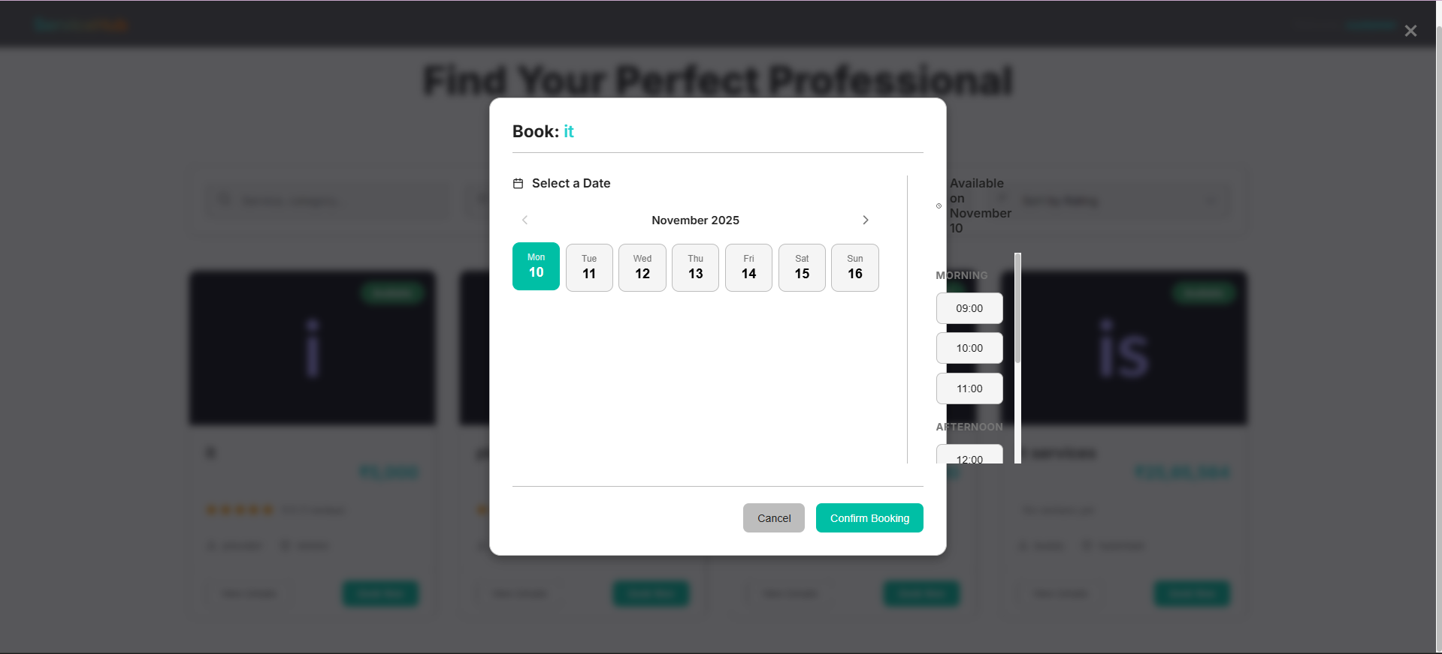
Figure 6: Customer Booking

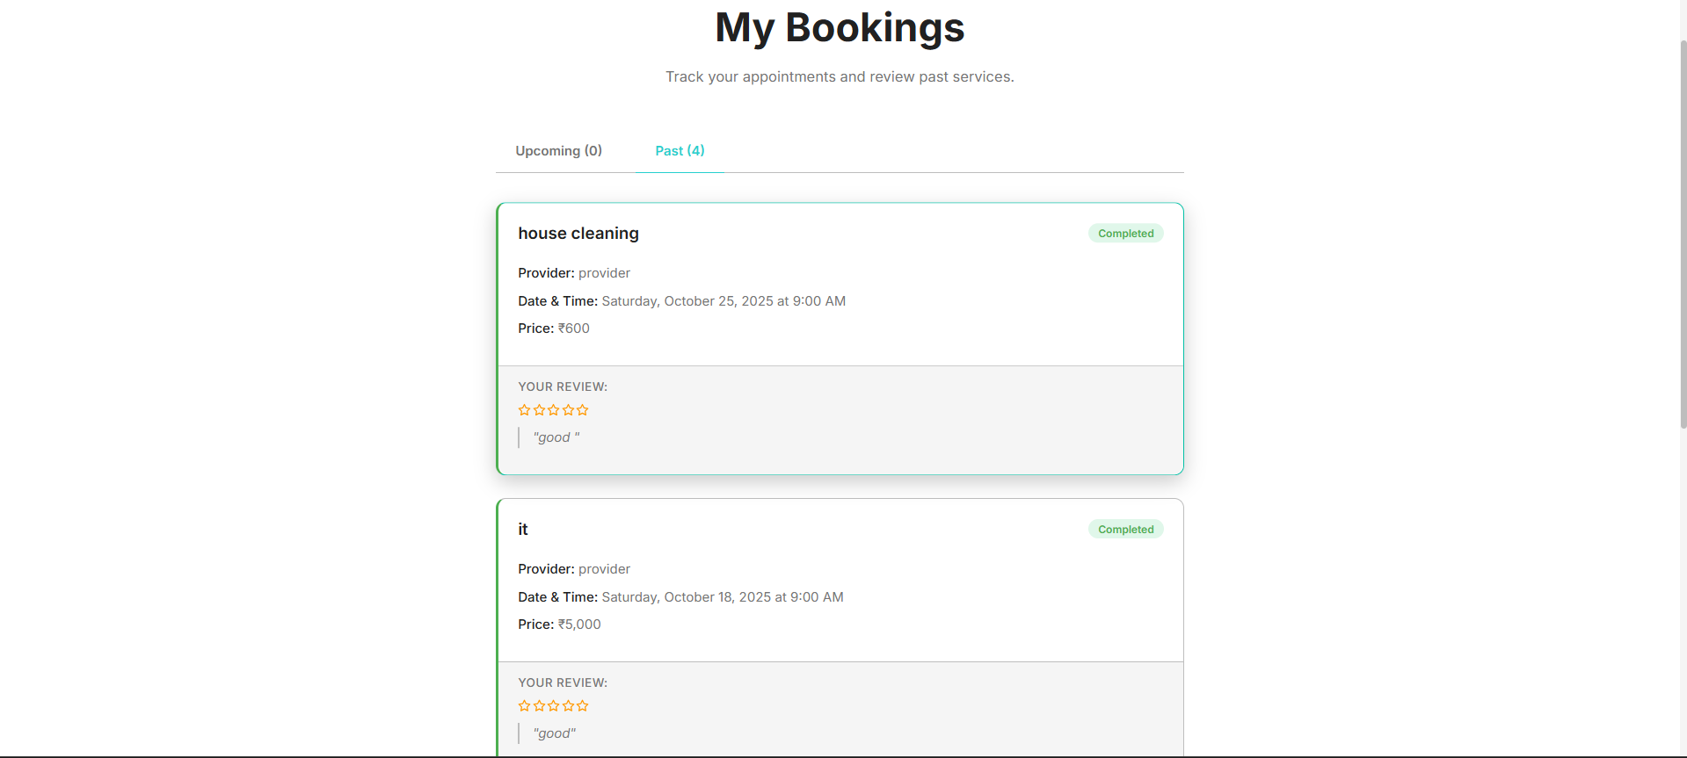

Figure 7: Booking Page

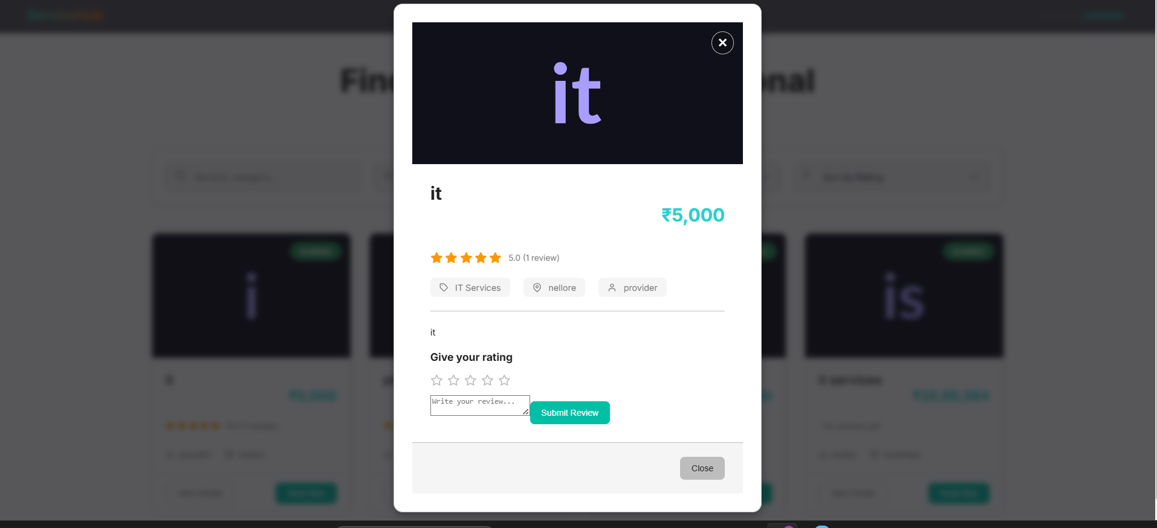

Figure 8: Review Page
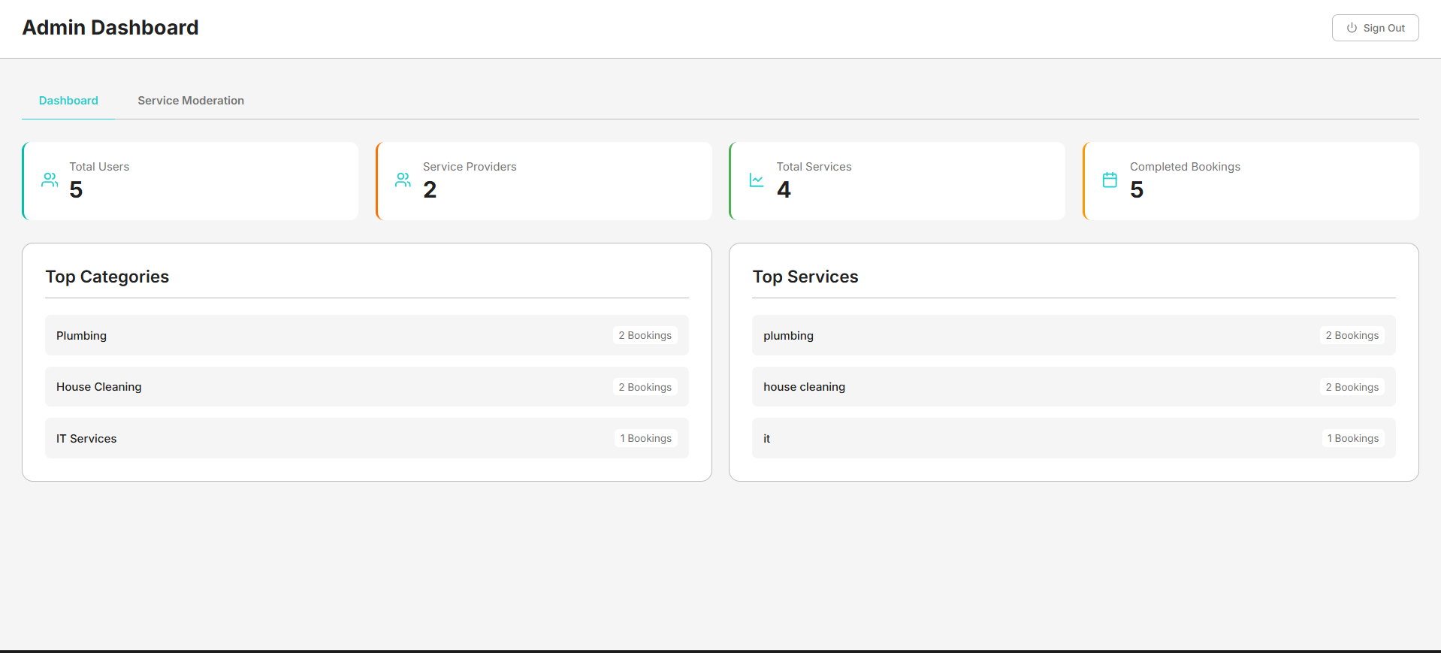

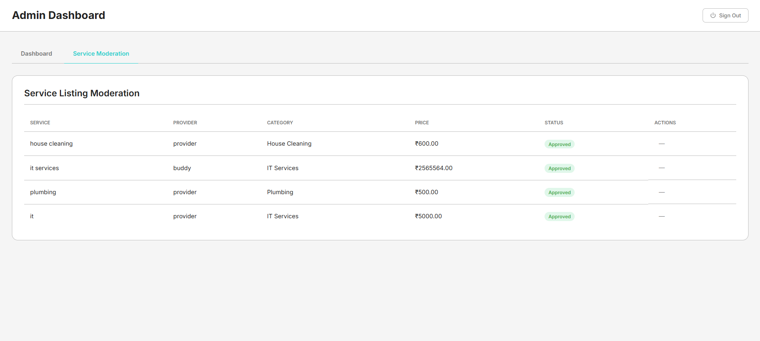
Figure 9: Admin Panel

7. Challenges Faced
During the development and execution of the Local Services Finder and Booking Platform, the project team encountered several technical, design, and coordination challenges. These challenges provided valuable learning experiences and helped refine the system’s functionality and stability. The key challenges faced during the project are detailed below:
1. Integration of Role-Based Authentication
One of the primary challenges was implementing a secure and efficient role-based login system that distinctly separated customer, service provider, and admin functionalities. Ensuring that each role accessed only authorized features required careful session management and validation logic. Initially, role conflicts caused dashboard redirection issues, which were later resolved through refined user role mapping and improved authentication flow.
2. Real-Time Booking Synchronization
Managing real-time booking updates between customers and service providers proved complex. When multiple users attempted to book the same service slot simultaneously, data inconsistency issues arose. To address this, database-level transaction control and concurrency handling mechanisms were implemented, ensuring that once a time slot was booked, it was immediately marked unavailable for others.
3. Database Design and Optimization
Designing a normalized and efficient database structure that could handle dynamic data for services, users, and bookings was challenging. In the early stages, redundant tables caused slow query responses and data duplication. This issue was overcome by redesigning the schema with proper foreign key relationships and indexing, which significantly improved query performance.
4. UI/UX Consistency Across Modules
Maintaining a consistent user interface across multiple dashboards (Customer, Provider, and Admin) required continuous coordination among the team. Initial layouts lacked uniformity and responsiveness. The issue was mitigated by adopting a standardized design framework and applying CSS-based reusable components to ensure a seamless and professional interface across all devices.
5. Handling Data Validation and Security
Another significant challenge was ensuring data integrity and security. Input validation errors, such as incomplete forms or invalid data formats, initially caused disruptions in form submissions. Moreover, preventing unauthorized data access and potential SQL injection attacks required implementing server-side validation and using prepared statements for database queries.
6. Implementation of Geo-Based Search
Integrating the feature that filtered services based on users’ geographical location required external API usage and data mapping logic. The challenge was ensuring accuracy and performance while keeping the response time minimal. The team optimized this by using efficient geolocation libraries and caching frequently accessed locations for faster retrieval.
7. Testing and Bug Fixing
With multiple modules interacting dynamically, identifying and fixing bugs during integration was time-consuming. Some features, such as booking status updates and feedback submission, initially failed to sync properly across user dashboards. These were resolved through repeated testing cycles, including unit, integration, and user acceptance testing, ensuring smooth end-to-end functionality.
8. Time Management and Coordination
As the project involved multiple developers working on different modules, coordinating tasks and merging code changes was occasionally difficult. Version control conflicts occurred during the integration phase. This was managed by using GitHub branches effectively, conducting frequent team meetings, and maintaining clear documentation of module progress.

8. Learnings & Skills Acquired
Throughout the execution of the Local Services Finder and Booking Platform project, the team gained substantial technical knowledge, problem-solving ability, and collaborative experience. The project served as a comprehensive learning opportunity, enhancing both technical and professional competencies essential for real-world software development. The major learnings and skills acquired are detailed below:
1. Enhanced Understanding of Full-Stack Development
The project provided hands-on experience in building a complete full-stack web application from the ground up. The team learned how to integrate front-end and back-end technologies efficiently. Working with Java for the server-side logic, HTML, CSS, and JavaScript for the client interface, and MySQL for data management improved the understanding of how each layer of an application interacts to deliver a cohesive system.
2. Mastery in Java Programming and Database Connectivity
Developing core functionalities using Java enhanced programming proficiency and logical structuring skills. The team learned to use JDBC and Servlets for smooth communication between the application and the database. This experience strengthened the understanding of database operations such as CRUD functionalities, transactions, and secure query handling using prepared statements.
3. Implementation of Role-Based Authentication Systems
Through the process of designing and executing separate dashboards for different user roles, the team gained practical knowledge of session management, access control, and secure authentication mechanisms. This skill is particularly valuable in developing scalable enterprise-level web applications.
4. Improved Problem-Solving and Debugging Techniques
Facing real-time issues during development—such as concurrency conflicts, inconsistent UI, and data validation errors—enhanced the team’s debugging and analytical capabilities. By learning how to isolate, reproduce, and fix problems, the members became more proficient in troubleshooting under deadlines.
5. Better Understanding of UI/UX Design Principles
While designing an intuitive interface for both customers and service providers, the team learned the importance of simplicity, clarity, and visual consistency in web applications. They also gained experience in responsive web design and the use of CSS for creating interactive and appealing layouts.
6. Knowledge of Software Development Lifecycle (SDLC)
The project followed a structured, phase-wise development model similar to the SDLC, covering requirement analysis, design, implementation, testing, and deployment stages. This exposure gave the team a clear understanding of how professional software projects are planned, executed, and maintained.
7. Familiarity with Git and Version Control Systems
By collaborating through GitHub, the team learned how to manage code versions, resolve merge conflicts, and coordinate multiple modules effectively. This also introduced best practices such as committing regularly, writing meaningful commit messages, and maintaining clean repository structures.
8. Strengthened Team Collaboration and Communication Skills
Working as a team required regular discussions, updates, and division of tasks. The members developed teamwork, leadership, and time management skills, which are critical for completing projects efficiently. It also encouraged mutual learning and accountability among team members.
9. Experience with Real-Time Data and Dynamic Features
Building modules such as the booking calendar and rating system helped the team understand how real-time data updates work. Implementing dynamic features like booking confirmation, slot availability, and feedback tracking gave practical experience in handling asynchronous data and maintaining application state effectively.
10. Exposure to Project Documentation and Reporting
Preparing formal reports, diagrams, and technical documentation during each milestone improved the ability to present technical work in a clear and professional format. This practice also emphasized the importance of maintaining structured documentation for future maintenance and scalability.

9. Testimonials from team
The development of the Local Services Finder and Booking Platform was not only a technical milestone but also a highly collaborative learning experience. Each team member contributed their skills, ideas, and dedication toward the successful completion of the project. The following testimonials reflect the individual experiences, insights, and growth achieved during the project journey.
Neha Sadhvi Polepaka
“Working on this project gave me the opportunity to apply my Java and web development knowledge to a real-world problem. I learned the importance of structuring code efficiently, managing databases, and ensuring smooth interaction between different modules. This project strengthened my confidence in backend development and enhanced my understanding of full-stack application design.”
Rithika
“This project was an incredible learning journey for me. Collaborating with the team helped me improve my problem-solving abilities and taught me how to handle challenges effectively. I especially enjoyed working on the user interface part, where I learned the importance of creating a seamless and user-friendly experience for both customers and service providers.”
Aditya
“Being part of this project taught me how teamwork and coordination play a vital role in software development. I learned to integrate different modules smoothly and to test functionalities effectively. Working on the database and booking module helped me understand how to manage data flow, handle concurrency, and ensure data accuracy.”
Durvesh
“This project gave me hands-on experience in implementing real-time features like bookings and feedback. I learned about API integration, efficient coding practices, and testing techniques that are essential for building reliable web applications. The teamwork, brainstorming sessions, and learning environment made this project truly memorable.”
Guided by: Maheshvaran (Mentor)
“The team demonstrated excellent collaboration, consistency, and innovation throughout the project. Each member showed great initiative in solving problems independently while maintaining effective teamwork. Their dedication and willingness to learn ensured that the project was completed successfully with high quality and professionalism.”

10. Conclusion
The Local Services Finder and Booking Platform project successfully achieved its objective of creating a user-friendly, efficient, and reliable system that bridges the gap between customers and local service providers. Through systematic planning, modular implementation, and continuous testing, the team was able to design and develop a complete web-based solution that supports real-time service discovery, booking, and feedback mechanisms.
The project emphasized practical application of technical knowledge in Java, web technologies, and database management, providing hands-on experience in full-stack development. By integrating multiple functionalities such as role-based authentication, listings management, booking calendar, and rating systems, the platform delivers a comprehensive solution to address real-world service accessibility challenges.
Throughout the development process, the team not only strengthened their technical expertise but also developed essential soft skills such as teamwork, communication, and time management. The experience of overcoming various challenges—ranging from database optimization to user interface consistency—helped the members grow both personally and professionally.
From an implementation perspective, the project demonstrates how digital platforms can simplify everyday tasks by enabling users to find, book, and review services in their locality with ease. The system also offers scalability and future scope for enhancements such as integrating payment gateways, GPS-based real-time tracking, and AI-driven service recommendations.
In conclusion, the Local Services Finder and Booking Platform stands as a successful outcome of innovation, collaboration, and problem-solving. It serves as a practical demonstration of how technology can be leveraged to make community-level service interactions more organized, transparent, and efficient.

11. Acknowledgements

We would like to express our sincere gratitude to Infosys Springboard for providing us with the invaluable opportunity to complete this internship. This experience has been both challenging and rewarding, offering us deep insights into Full Stack Development and contributing significantly to our technical knowledge and professional growth.
We are especially grateful to our mentor, Mr. Maheshvaran, for his constant guidance, patience, and encouragement throughout this journey. His expert advice, insightful feedback, and unwavering support helped us overcome obstacles and complete the project successfully. His mentorship inspired us to think critically, work collaboratively, and approach challenges with confidence.
We would also like to extend our heartfelt thanks to our teammates — Neha Sadhvi Polepaka, Rithika, Adithya, and DurveshAli — for their consistent effort, cooperation, and dedication. Every member contributed their unique strengths to ensure the project’s success, creating a positive and collaborative environment where ideas could be freely shared and implemented effectively.
This internship has been a remarkable learning experience that enhanced both our technical and interpersonal skills. We are truly grateful to everyone who supported and guided us throughout this journey.

